Custom Start Month for Your Calendar
Hello [Customer First Name],
Thank you for contacting Printerpix.
You can choose any month of the year as the starting month for your calendar. This option is available at the beginning of the design process, as shown in the screenshot below:

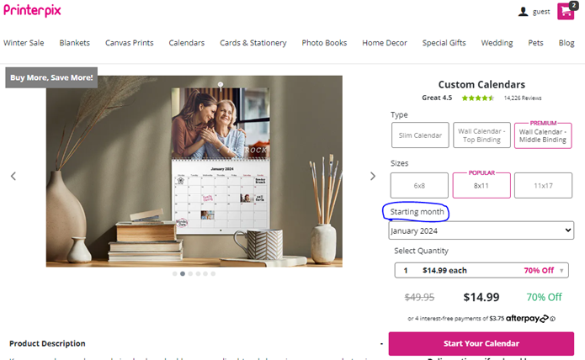

If you have any further questions or need assistance with anything else, please don’t hesitate to reach out. I’ll be happy to help.

Can I change my book type
Hello (Customer First Name),
Thank you for contacting Printerpix.

Unfortunately, it isn’t possible to change the book type or size once a project has been created. Each book type and size has its own unique layout and formatting, so switching to a different option (for example, from leather cover to hardcover, or from 8x11 to 11x14) would require starting a new project and redesigning it accordingly.

If you have any further questions or need any assistance, please feel free to reach out. I’d be happy to help.

If you have any further questions or need assistance, please feel free to contact me—I'd be happy to help.

How do I know what my order will look like
Hello (Customer First Name),
Thank you for contacting Printerpix.
You can click on the "Preview" option located next to the "Add to Cart" button. This allows you to see exactly how your order will appear. Your final product will be printed exactly as shown in the preview.

If you have any further questions or need assistance, please feel free to contact me—I’d be happy to help.

How to upload Photos in Chronological Order
Hello (Customer First Name),
Thank you for contacting Printerpix.
I sincerely apologize for the inconvenience you’ve experienced while creating your project.
Please note that the Printerpix website does not currently support automatically uploading photos in chronological order. Each image must be added individually from your account. We understand this can be time-consuming, and we apologize for any inconvenience this may cause. Our platform is designed to guide you through the process as smoothly as possible, and we’re here to support you along the way.
If you have any further questions or need assistance at any point, please don’t hesitate to reach out—I’ll be happy to help.

Assistance with Your Project:

Hello (Customer First Name),
Thank you for reaching out to Printerpix.
I sincerely apologize for the difficulties you’ve encountered while creating your project.
To help resolve the issue, I recommend using an incognito tab in Google Chrome. You can do this by clicking on the three dots in the top right corner of the Chrome browser. Select "New Incognito Window," then visit our website, log into your account, and try uploading your pictures again. The error you’re experiencing may be due to server lag.
Please note that we only accept pictures in JPG format. Formats such as PNG, GIF, and SVG are not accepted.
If you have any further questions or concerns, or if you would like to discuss anything in more detail, please feel free to contact me. I’m here to help!
Thank you.
Best regards,
Agent Name

